# **Gravitoelectromagnetism**

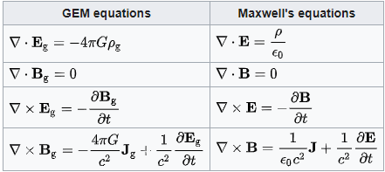

* **E**g is the [static gravitational field](https://en.wikipedia.org/wiki/Gravitational_field) (conventional [gravity](https://en.wikipedia.org/wiki/Gravity), also called *gravitoelectric* in analogous usage) in m⋅s−2;
* **E** is the [electric field](https://en.wikipedia.org/wiki/Electric_field);
* **B**g is the gravitomagnetic field in s−1;
* **B** is the [magnetic field](https://en.wikipedia.org/wiki/Magnetic_field);
* *ρ*g is [mass density](https://en.wikipedia.org/wiki/Density) in kg⋅m−3;
* *ρ* is [charge density](https://en.wikipedia.org/wiki/Charge_density):
* **J**g is mass current density or [mass flux](https://en.wikipedia.org/wiki/Mass_flux) (**J**g = *ρ*g**v**ρ, where **v**ρ is the [velocity](https://en.wikipedia.org/wiki/Velocity) of the mass flow generating the gravitomagnetic field) in kg⋅m−2⋅s−1;
* **J** is electric [current density](https://en.wikipedia.org/wiki/Current_density);
* *G* is the [gravitational constant](https://en.wikipedia.org/wiki/Gravitational_constant) in m3⋅kg−1⋅s−2;
* *ε*0 is the [vacuum permittivity](https://en.wikipedia.org/wiki/Vacuum_permittivity);
* *c* is the [speed of propagation of gravity](https://en.wikipedia.org/wiki/Speed_of_gravity) (which is equal to the [speed of light](https://en.wikipedia.org/wiki/Speed_of_light) according to [general relativity](https://en.wikipedia.org/wiki/General_relativity)) in m⋅s−1.

**Lorentz force**

For a test particle whose mass *m* is "small", in a stationary system, the net (Lorentz) force acting on it due to a GEM field is described by the following GEM analog to the [Lorentz force](https://en.wikipedia.org/wiki/Lorentz_force) equation:



* **v** is the [velocity](https://en.wikipedia.org/wiki/Velocity) of the [test particle](https://en.wikipedia.org/wiki/Test_particle);
* *m* is the [mass](https://en.wikipedia.org/wiki/Mass) of the test particle;
* *q* is the [electric charge](https://en.wikipedia.org/wiki/Electric_charge) of the test particle.

### Poynting vector

The GEM Poynting vector compared to the electromagnetic [Poynting vector](https://en.wikipedia.org/wiki/Poynting_vector) is given by:[[11]](https://en.wikipedia.org/wiki/Gravitoelectromagnetism#cite_note-11)

